**This document combines the information (tables & important notes) that is mentioned in below two links:**

* <https://docs.unity3d.com/Manual/OpenVRControllers.html>
* <https://docs.unity3d.com/Manual/Windows-Mixed-Reality-Input.html>

### HTC Vive controllers

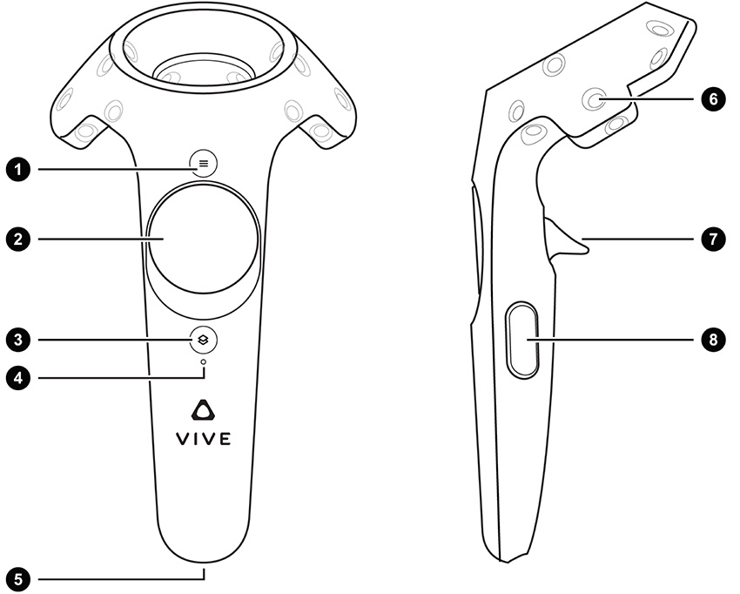

| 1 | Menu Button |
| --- | --- |
| 2 | Trackpad |
| 3 | System button |
| 4 | Status light |
| 5 | Micro-USB port |
| 6 | Tracking sensor |
| 7 | Trigger |
| 8 | Grip button |

### Oculus Touch controllers

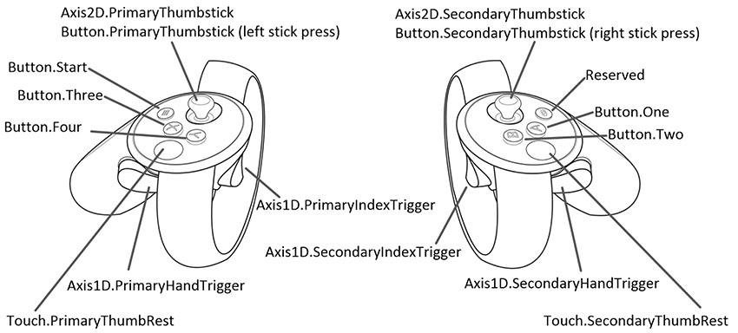

**Knuckles controllers**

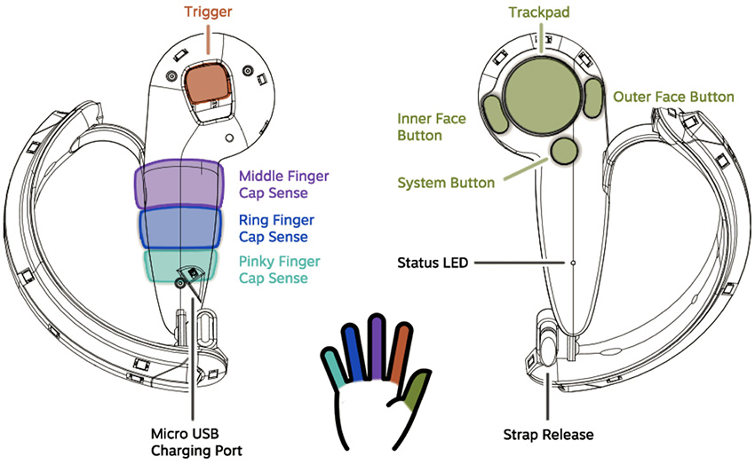

# **Windows Mixed Reality**

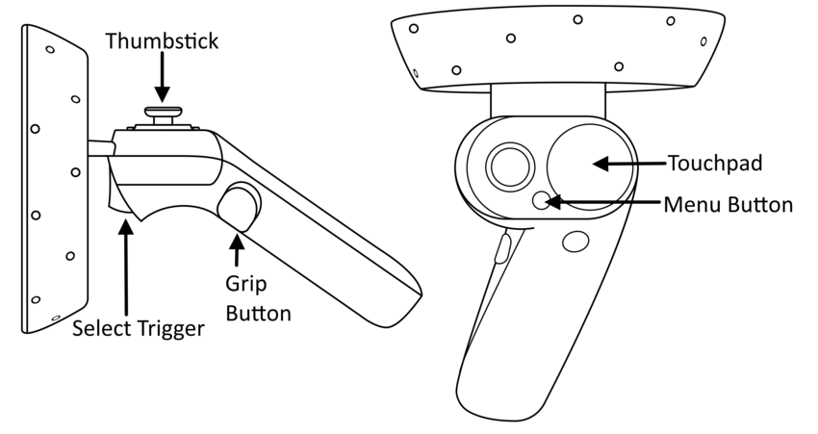

The table below lists the different axes available when using Window Mixed Reality controller inputs, along with the positive and negative directions for each axis.

| **Axis** | **Positive Direction** | **Negative Direction** |
| --- | --- | --- |
| Horizontal | Left | Right |
| Vertical | Up | Down |

|  |  |  |  |  |  |  |  |  |
| --- | --- | --- | --- | --- | --- | --- | --- | --- |
| General Types | HTC Vive Controller | Oculus Touch Controller | Windows Mixed Reality Controller | Valve Knuckles Controller | Interaction Type | Unity Button ID | Unity Axis ID | Unity Axis Value Range |
| Menu | Left Controller Menu Button (1) | Button.Three |  | Left Controller Inner Face Button | Press | 2 |  |  |
| Right Controller Menu Button (1) | Button.One |  | Right Controller Inner Face Button | Press | 0 |  |  |
|  |  | Menu button (Left) |  | Press | 6 |  |  |
|  |  | Menu button (Right) |  | Press | 7 |  |  |
|  |  |  | Left Controller Outer Face Button | Press | 3 |  |  |
|  |  |  | Right Controller Outer Face Button | Press | 1 |  |  |
| *Vive:*  TrackPad  *Oculus:*  Thumbstick  *WMR:*  Touchpad  &  Thumbstick | Left Controller Trackpad (2) | Button.PrimaryThumbstick | Thumbstick (Left) | Left Controller Trackpad | Press | 8 |  |  |
| Right Controller Trackpad (2) | Button.SecondaryThumbstick | Thumbstick (Right) | Right Controller Trackpad | Press | 9 |  |  |
| Left Controller Trackpad (2) | Button.PrimaryThumbstick |  | Left Controller Trackpad | Touch | 16 |  |  |
|  |  | Touchpad (Left) |  | Press |
| Right Controller Trackpad (2) | Button.SecondaryThumbstick |  | Right Controller Trackpad | Touch | 17 |  |  |
|  |  | Touchpad (Right) |  | Press |
|  |  | Touchpad (Left) |  | Touch | 18 |  |  |
|  |  | Touchpad (Right) |  | Touch | 19 |  |  |
| Left Controller Trackpad (2) | Axis2D.PrimaryThumbstick | Thumbstick (Left) | Left Controller Trackpad | Horizontal Movement |  | 1 | –1.0 to 1.0 |
| Left Controller Trackpad (2) | Axis2D.PrimaryThumbstick | Thumbstick (Left) | Left Controller Trackpad | Vertical Movement |  | 2 | –1.0 to 1.0 |
| Right Controller Trackpad (2) | Axis2D.SecondaryThumbstick | Thumbstick (Right) | Right Controller Trackpad | Horizontal Movement |  | 4 | –1.0 to 1.0 |
| Right Controller Trackpad (2) | Axis2D.SecondaryThumbstick | Thumbstick (Right) | Right Controller Trackpad | Vertical Movement |  | 5 | –1.0 to 1.0 |
|  |  | Touchpad (Left) |  | Horizontal Movement |  | 17 | –1.0 to 1.0 |
| Vertical Movement | 18 |
|  |  | Touchpad (Right) |  | Horizontal Movement |  | 19 | –1.0 to 1.0 |
| Vertical Movement | 20 |
| Trigger | Left Controller Trigger (7) | Axis1D.PrimaryIndexTrigger |  | Left Controller Trigger | Touch | 14 |  |  |
|  |  | Select Trigger (Left) |  | Press |
| Right Controller Trigger (7) | Axis1D.SecondaryIndexTrigger |  | Right Controller Trigger | Touch | 15 |  |  |
|  |  | Select Trigger (Right) |  | Press |
| Left Controller Trigger (7) | Axis1D.PrimaryIndexTrigger | Select Trigger (Left) | Left Controller Trigger | Squeeze |  | 9 | 0.0 to 1.0 |
| Right Controller Trigger (7) | Axis1D.SecondaryIndexTrigger | Select Trigger (Right) | Right Controller Trigger | Squeeze |  | 10 | 0.0 to 1.0 |
| *Oculus:*  Trigger  *Vive & WMR:*  Grip | Left Controller Grip Button (8) | Axis1D.PrimaryHandTrigger | Grip Button (Left) | Left Controller Grip Average | Squeeze |  | 11 | Oculus: (0.0 to 1.0)  Vive & WMR: (0 or 1) |
| Right Controller Grip Button (8) | Axis1D.SecondaryHandTrigger | Grip Button (Right) | Right Controller Grip Average | Squeeze |  | 12 | Oculus: (0.0 to 1.0)  Vive & WMR: (0 or 1) |
|  |  | Grip Button (Left) |  | Press | 4 |  |  |
|  |  | Grip Button (Right) |  | Press | 5 |  |  |
|  |  |  |  | Left Controller Index Finger Cap Sensor |  |  | 20 | 0.0 to 1.0 |
|  |  |  |  | Right Controller Index Finger Cap Sensor |  |  | 21 | 0.0 to 1.0 |
|  |  |  |  | Left Controller Middle Finger Cap Sensor |  |  | 22 | 0.0 to 1.0 |
|  |  |  |  | Right Controller Middle Finger Cap Sensor |  |  | 23 | 0.0 to 1.0 |
|  |  |  |  | Left Controller Ring Finger Cap Sensor |  |  | 24 | 0.0 to 1.0 |
|  |  |  |  | Right Controller Ring Finger Cap Sensor |  |  | 25 | 0.0 to 1.0 |
|  |  |  |  | Left Controller Pinky Finger Cap Sensor |  |  | 26 | 0.0 to 1.0 |
|  |  |  |  | Right Controller Pinky Finger Cap Sensor |  |  | 27 | 0.0 to 1.0 |

Unity Touch Input events differ for each platform controller:

* The [Event System](https://docs.unity3d.com/Manual/EventSystem.html) generates Input Touch events for the triggers on HTC Vive controllers when the user begins squeezing the trigger.
* The [Event System](https://docs.unity3d.com/Manual/EventSystem.html)  generates Input Touch events for the triggers on Oculus Touch and Valve Knuckles controllers when [Unity Input](https://docs.unity3d.com/ScriptReference/Input.html) detects a touch - no trigger squeeze is necessary.